**Experiment Design**

Student's Name

Institutional Affiliation

Course

Professor's Name

Date

**Experiment Design**

**Independent Variables (IVs):**

**IV1: Mode of Expression**

Format in which the mathematical or programming task is expressed.

Options:

Numeric/Symbolic

English words

**IV2: Type of Task**

The type of task being performed, either mathematical problem solving or code generation.

Options for Mathematical Tasks:

Arithmetic, Multiplication, Algebra, Statistics

Options for Code Generation Tasks:

Data Analysis, Statistical Analysis, Data Visualization

**IV3: Complexity of Task**

The complexity of the task at hand, ranging from simple to complex.

Options:

Simple, Intermediate, Complex

**Dependent Variable (DV):**

Accuracy: How correctly the model answers the problem or generates the code.

# Step 1: Data Preparation

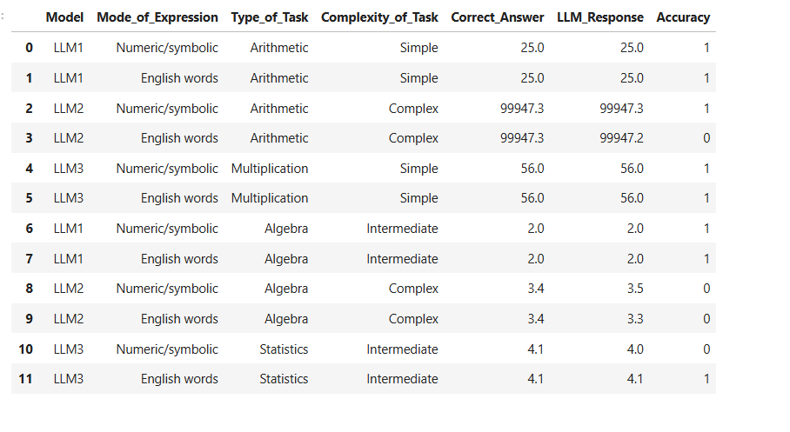

**Step 2: Analysis with ANOVA**

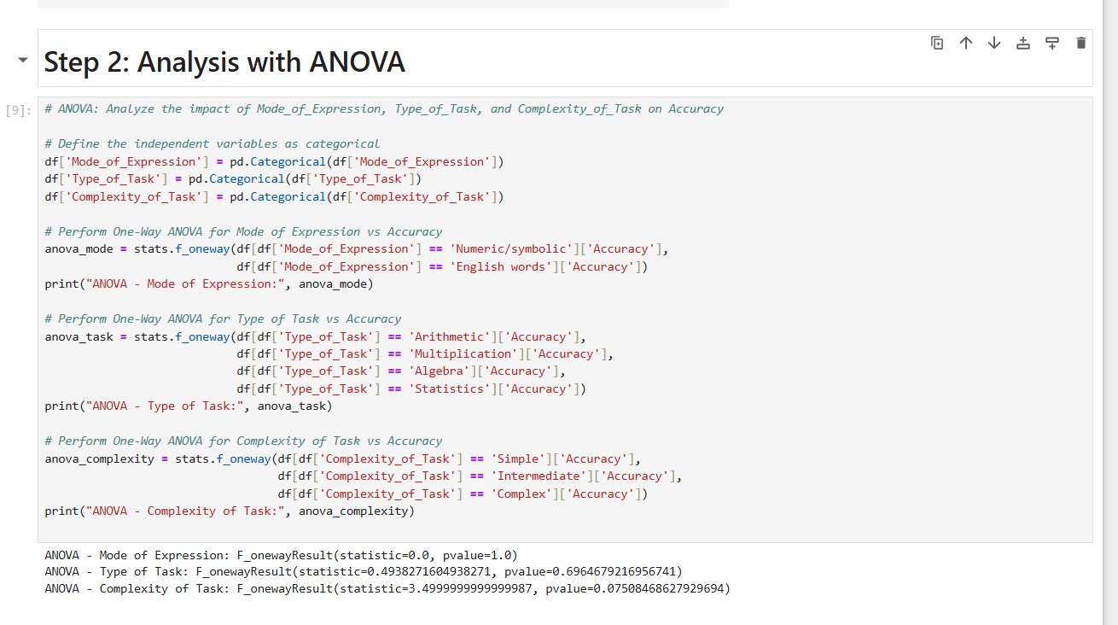 **Step 3: Visualizing the Results**

